SAE Aero Micro Class – Team 18
March 3, 2017
Midpoint Report
1. Background

1.1 Introduction

SAE International holds an annual Aero Design competition for colleges around the world to display radio-controlled aircraft designs of various sizes. This competition introduces students to the use of resources and efficient design in a real-world application. The competition is broken down into three sections: Micro Class, Regular Class, and Advanced Class. Professionals judge score each team based on Oral Presentation, Written Report, and Flight Results. SAE International is the primary sponsor for the competition. They are a global association of more than 128,000 engineers and related technical experts in the aerospace, automotive and commercial vehicle industries [1]. SAE brings in a variety of companies to judge and score the competition. These companies include Lockheed Martin, Meggitt, and Boeing. Those scoring the competition will recognize the most successful designs, providing opportunity for a future position within their companies. Our team has decided that giving a maximum effort to this competition will provide the best chance to seize this opportunity. Detailing the features of designs from previous winners will assist in creating the best design. In the aerospace industry today, engineers face many similar challenges. Conflicting requirements are a common occurrence in engineering applications, and it is a priority to incorporate the most of each requirement without jeopardizing the quality of the product.

1.2 Project Description

The SAE Aero Design competition provides undergraduate and graduate engineering students with a real-world design challenge. Engineering professionals designed the rules and regulations with the focus on educational value and hands-on experience through exposure to today’s technical and technology advancement. These rules compress a typical aircraft development program into one calendar year, taking participants through the system engineering process of breaking down requirements. It will expose participants to the nuances of conceptual design, manufacturing, system integration/test, and sell-off through demonstration. The micro class is an all-electric class designed to help students engage in trades between two potentially conflicting requirements, carrying the highest payload fraction possible, while simultaneously pursuing the lowest empty weight possible [2].

2. Requirements

2.1 Customer Requirements

The rules of the competition required the team to design a safe micro aircraft. There are many rules and regulations into designing the aircraft listed on the SAE website. The SAE International website has a three-page checklist in which the judges will use to score the aircrafts. Table 1 displays the checklist from SAE generalized by the team. The checklist describes the customer requirements for our project, since the team does not have an actual customer.

Table 1: Customer Requirements
Customer Requirements | Weighting  ( 5 Most Important )
Aircraft Identification | 2
Empty CG Design Requirement and Empty CG Markings | 5
Aircraft Conformance to 2D Drawing | 3
Aircraft uses a 2.4 GHz radio control system | 4
No metal prop | 3
No lead used in any portion of the aircraft or payload | 5
Payload does not contribute to the structural integrity of the airframe | 4
Ballast not installed in closed payload bay | 4
Ballast stations must be indicated on 2D drawing | 1
Ballast must be properly secured to avoid shifting or falling off the aircraft | 5
Aircraft is powered only by the Engines/Motors | 4
All servos properly sized for aircraft | 5
All linkages secure | 5
Aircraft Container | 3
Payload dimensions | 5
Payload removable side | 4
Payload prevent weight shifting | 5
Payload must be removable | 2
Battery ( 3 cell 2200 mAh) | 5
Safety | 5
High Lift | 5

2.2 Engineering Requirements

The team created a list of engineering requirements based off the competition rules and regulations. The team understood that specific values for requirements help create the actual design for the aircraft. The list below in table 2 shows the engineering requirements that the team agreed on as well as the weightings and tolerances for each.

Table 2: Engineering Requirements
Engineering Requirements | Weighting  (5 Most Important) | Tolerances
Safety – Functional motor shutoff switch (turn off within 5 seconds) | 5 | +0 / - 1.0 second
Weight – Less than 3.18 kg | 4 | +/- 0.5 kg
Durable – Able to withstand impact force of 22 N-s | 3 | +/- 2.0 N-s
High Payload Fraction – Greater than 0.75 (at max load) | 5 | + ∞/ - 0
Lift – Greater than 32 N | 5 | + ∞/ - 0

2.3 Testing Procedures

The team tested the aircraft flying it outside in Flagstaff, AZ. The team had the aircraft fly in a single circular formation and tested the landing in the grass. The team also tested assembly time by assembling the aircraft after taking it out of the container.

2.4 Design Links

The Society of Automotive Engineers list all of the rules and regulations on their website. The link to the website is below.
http://students.sae.org/cds/aerodesign/west/

2.5 House of Quality

The house of quality provided information on the importance and relation of engineering qualities to each other regarding the team’s project. The team collected the most important requirements from table 1 and formed them into the house of quality. The house of quality also allows the team to set desired quantities for values such as the velocity of the plane, the coefficient of lift that the wings produce, weight of the aircraft, and various other important aspects. Figure 1 displays the house of quality for our design.

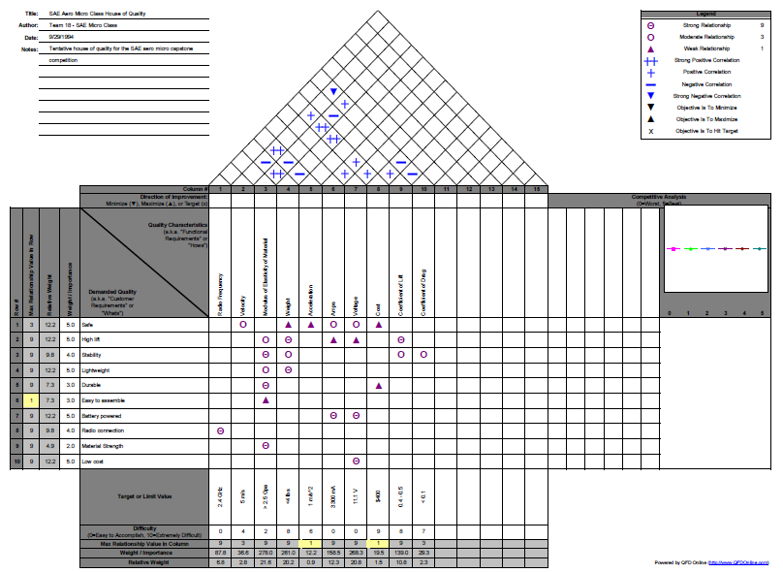
Figure 1: House of Quality

3. Existing Designs

3.1 Design Research

The team found lift as a top priority in the design of the micro aircraft. To optimize lift of the micro aircraft, the team researched the shape, aerodynamic efficiency, and the area of the wing. The following presented are three current designs of airplanes that were considered for the application of a micro remote control airplane: flying wing, three surface aircraft, and square wing.

3.2 System Level

3.2.1 Three Surface Aircraft

The first design was the three surface aircraft. A canard, mid-wing, and tailplane comprise the main features of the three surface aircraft [3]. The mid-wing, which is usually located along the plane’s center of gravity, provides the planes main source for lift. The canard is a wing that is located at the nose of the plane and helps maintain stability as well as lift. The tailplane varies from multiple designs, but compares to a normal aircraft’s tail. If there is more surface area and from the lift equation, equation 3.2.1, it is proven that lift is directly proportional to area.

 | $$L=\frac{1}{2}ρV^{2}SC_{l}$$ | (3.2.1)
Where,

L = Lift
Ρ = Density of Air
V = Velocity of Aircraft
S = Cross Sectional Wing area
C_{l} = Coefficient of Lift

Figure 2 displays the three surfaced aircraft.

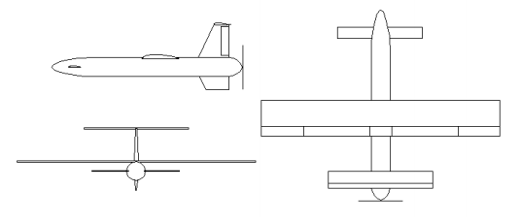
Figure 2: Three Surfaced Aircraft Design

3.2.2 Flying Wing

The second design was the flying wing. Previous knowledge of flying wings used for remote control aircrafts are attributed to NASA’s research. The flying wing design is a tailless aircraft composed of a solid-bodied wing and no definite fuselage. As described by NASA, the flying wing provides an aircraft that produces a proverse yaw [4]. Proverse yaw is thrust created at the tips of the flying wing, rather than drag. Proverse yaw produced on the aircraft’s wing tips makes the ability of flight possible without a tail. The flying wing replaces the tail, elevator, and rudder for split ailerons. Split ailerons are located on either side of the wing and can be deployed simultaneously or asynchronously to create lift and drag or yaw. Figure 3 shows an image of the flying wing.

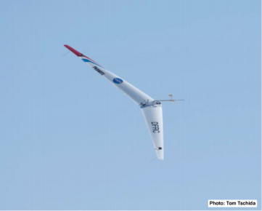
Figure 3: Flying Wing

3.2.3 Square Wing

The third design, square wing, is a typical wing of an average remote control airplane. This design is compiled of an aircraft with a fuselage, vertical/ horizontal stabilizer, elevator, rudder, and square wing. Attaching the square wing at the lower parts of the fuselage optimizes the aircraft. [5]. By placing the wing on the lower part of the fuselage, the plane can carry larger loads, become more acrobatic, and increase speed because of the equal lift distribution from tip to tip [5]. Figure 4 displays the basic prototype of a square wing.

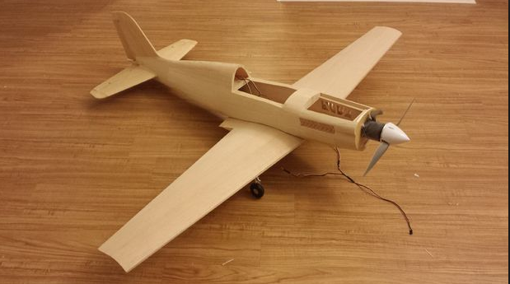
Figure 4: Square Wing

3.3 Subsystem Level

Each system level discussed previously has advantages and disadvantages. The team analyzed each system according to four subsystems. The team considered lift, weight, cost, and stability as appropriate subsystems to analyze each existing design.

3.3.1 Lift

The first subsystem level is lift. Lift is defined as the upward force that brings the aircraft into the air. Without a sufficient amount of lift, the plane remains on the ground. The three surface aircraft boasts the highest lift due to the canard. The flying wing has a low lift due to its low aspect ratio. The aspect ratio is known as the length of wings divided by the width of the wings [6]. In general, the higher the aspect ratio, the higher the lift produced by the wings. The square wing provides a good amount of lift at low speeds, but falters at higher velocities [7]. Since the competition will not require the plane to show off a high velocity, this could be an ideal design. The square wing’s aspect ratio is also high because of the long wing length as opposed to the width.

3.3.2 Weight & Cost

The team decided to group weight and cost into the same section because they have a moderate correlation with each other. The more weight that is added to the plane, the higher the cost of the aircraft will be. Since the aircraft is being tested for the highest payload fraction, weight is essential for the team to consider. Cost is critical to this project because the team was only given $1,500 to use for registration, design, materials, and travel. The cost of the plane must be cheap in order to efficiently use the budget provided to the team by Northern Arizona University (NAU). For the three surface aircraft, the weight and the cost will both be higher than the other designs because of the extra material used to make the canard. The flying wing has a low weight because it does not have a fuselage or a stabilizer. Because of this, the team would only be using two servos for this design. The reduced amount of material and the absence of the fuselage and stabilizer means that this design has the lowest cost. The square wing design has a moderate weight and cost. It does not have as much material as the three surface aircraft but it isn’t as light as the flying wing.

3.3.3 Stability and Functional Model

The final subsystem is stability. Stability is an important factor in the aircraft because without a stable design, the plane can get out of control while flying causing a crash and possibly being disqualified from the competition. The three surface aircraft has a lower stability because of its shorter tail. The flying wing’s stability is the worst out of the three designs due to the absence of the stabilizer [8]. The square wing falls between the three surface aircraft and the flying in terms of stability. The stability of the square wing is good but it could be better with added wings like the three surface design. A functional model depicts how the requirements from the SAE website lead into the design requirements that the team set created. The functional model can be found in table 3.
Table 3: Functional Model
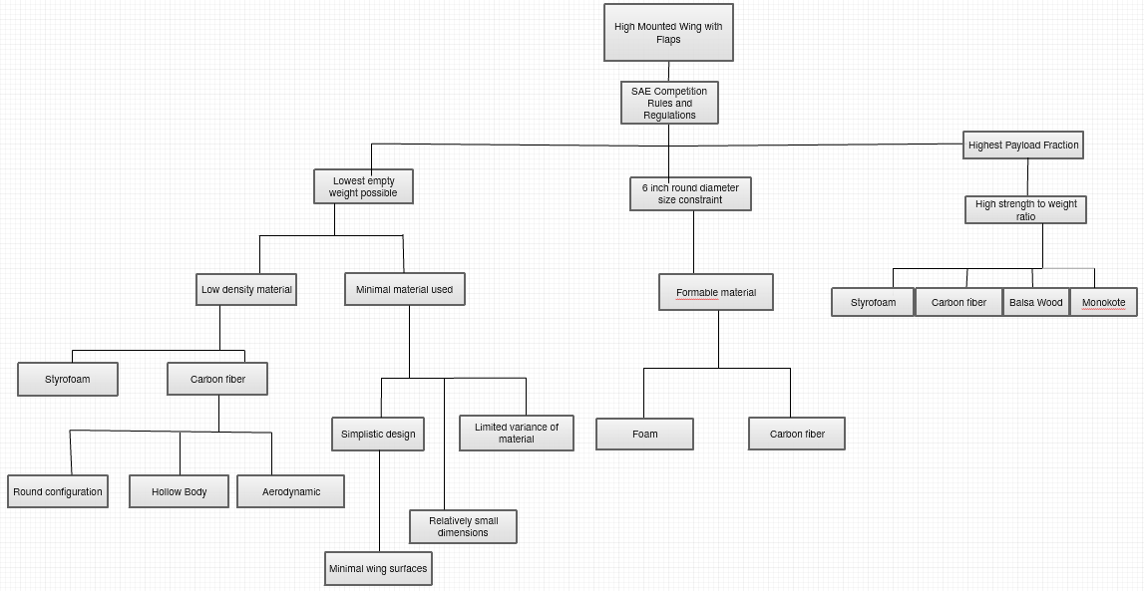

4. Designs Considered

The team realized that cutting down the potential designs to three designs limits the team’s creativity. Instead of only deciding between the square wing, flying wing, and the delta wing designs, the team decided to think of parts separately and make a table combining all the parts together. The parts that the team decided to look at separately were the wing design, airfoil, material, motor, motor position, number of blades on the propeller, and the body type. Table 4 lists the potential designs that the team thought of using for separate aspects of the aircraft.

Table 4: Designs Considered
Concept | Wing | Airfoil [9] | Material | Motor | Motor Position | Propeller | Body
1 | Square -Mounted High | PT-40 | Foam | Single Brushless | Front | 2 – Blade | Carbon Fiber Rod
2 | Flaps | Falcon 56 Mark II | Foam | Twin Brushless | Middle | 2 –Blade | Square Foam
3 | Expandable | Clark Y-14 | Monokote | Single Brushless | Front | 2 –Blade | Carbon Fiber Rod
4 | Delta Wing | Trainer 60 | Balsa/ Monokote | Twin Brushless | Rear | 3 – Blade | Square Foam
5 | Biplane | Clark Y-14 | Foam | Single Brushless | Front | 3 – Blade | Carbon Fiber Rod
6 | Three Surface | PT -40 | Balsa / Monokote | Single Brushless | Rear | 3 – Blade | Streamline Foam
7 | Flying Wing | DH4009 | Foam | Single Brushless | Rear | 2 – Blade | N/A
8 | Square -Mounted low | Clark Y-14 | Foam | Single Brushless | Front | 2 – Blade | 3D – Flat
9 | Flying Disk | N/A | Plastic | Single Brushless | Middle | 3 – Blade | Circular
10 | Square -Mounted middle | Clark Y-14 | Balsa/ Monokote | Twin Brushless | Middle | 3 – Blade | Square Carbon Fiber

After creating a list of potential designs for the competition, the team created a table to list the advantages and disadvantages of each concept. Table 5 below shows the table created by the team. The table convinced the team that certain concepts were not viable for the competition. For example, the biplane wings are too heavy to have a high payload fraction, even though they provide a high amount of lift.

Table 5: Advantages and Disadvantages of Concepts
Concept | Advantages | Disadvantages
1 | -Greater lift/ Stability  -Lightweight | -Flexible  -Low Power
2 | -Greater lift when deployed | -Must be deployed for extra lift  -Square body not aerodynamic
3 | -Fits size constraint | -Can collapse  -Possibly too light
4 | -High speed  -Twin motors provide more thrust | -May not fit size constraint  -Heavy
5 | -Stable  -High lift | -Greater drag  -Heavy
6 | -More surface area for maximum lift  -Stable | -Heavy  -Greater drag and weight
7 | -Light weight  -Streamline | -May not fit size constraint unless designed in sections
8 | -High speed  -Stable | -Without power will not glide (instant crash)  - Less lift
9 | -Aesthetically pleasing | -Unpractical  -Minimal control
10 | -Acrobatic  -Moderate lift | -Less thrust from propeller  - Without power will not glide (instant crash)  - Drag induced from square body

5. Designs Selected

5.1 Rationale for Design Selection

5.1.1 Material Analysis

The goal of the material analysis is to maximize lift while determining which material has the least weight. In addition to these constraints, the material that is selected will also influence the empty weight, payload, in-flight stability, durability, as well as cost. Based on the rules and regulations of the SAE Micro Aero competition, foam, carbon fiber, and balsa wood were chosen to be analyzed.

5.1.1.1 Assumptions

Multiple assumptions are made for to solve the assumption driven equations. The first assumption made is a thin square airfoil with a length of 36” and a width of 5.95”. Since the airfoil is assumed thin, the thickness may be ignored. To save weight the fuselage is constructed of a single circular rod that is 36” in length. The diameter of the rod will be determined from the stress equations. The center of gravity of the plane is defined at 3.5” from the nose of the plane. For the plane physical flying limitation, the speed of the plane must be less than or equal to 30 feet per second and the angle of attack must be at a minimum of 4 degrees and a maximum of 6 degrees. Shown below in figure 5 is a schematic of what has been defined.

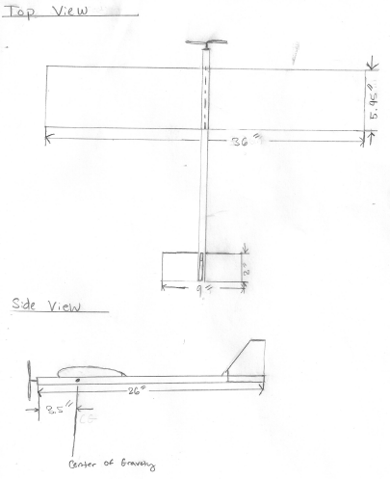
Figure 5: Top and Side View of Fuselage and Wing
From these assumptions maximum lift is calculated which will help construct a bending moment diagram. The bending moment diagram will help yield the maximum stresses along the fuselage and wing. For the wing, stresses will be translated to the materials yield strength; therefore, the material producing the best results will be selected. For the fuselage, the bending stress equation will be used to find the diameter of the circular rod. The selected material’s density and dimensions will conclude which material is the lightest.

Based on the previous equations used, variables are defined as:

L = Lift (N)
ρ = Density (kg/m³)
V = Velocity (m/s)
A = Area (m²)
C_{L} = Lift coefficient (dimensionless)
σ = Bending stress (Pa)
τ = Shear stress (Pa)
M = Bending moment (N-m)
y = Distance from the neutral axis (m)
I = Moment of inertia (m⁴)
v = Shear force (N)
D = Diameter (m)

To find the max lift force acting on half the wing, equation 5.1.1.1 is shown below [10].

 | $$L=\frac{1}{2}ρV^{2}AC_{L}$$ | (5.1.1.1)

Using the assumptions previously listed, velocity equals 30 ft/s = 9.144 m/s, area is equal to 0.15113 m, density is equal to 1.225 kg/m³, and C_{L} is equal to 2πϴ (where theta is in radians and equal to 0.10472 rad). Plugging all values into the equation, equation 1, yields L_{max}= 2.328 N acting on the middle of half the wing (for further calculations check appendix A). L_{max} may then be used to determine the bending moment diagram at half the wing, shown below in figure 6.

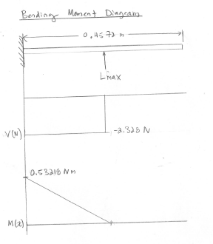
Figure 6: Bending Moment Diagram of Max Lift Acting on Half of the Wing

From the bending moment diagram the max bending and shear stress can be calculated. Respectively equations 5.1.1.2 and 5.1.1.3 display the bending and shear equations for a rectangular cross-section [11].

 | $$σ_{max}=\frac{My}{I}$$ | (5.1.1.2)
 | $$τ_{max}=\frac{3V}{2A}$$ | (5.1.1.3)

Using the calculated values from figure 6, equations 5.1.1.2 and 5.1.1.3 yield, σ_{max} = 14554.9 Pa and τ_{max}= 606.5 Pa. Comparing these values to the yield strength of balsa wood, 15 MPa [12], and foam, 13.8 [13] MPa, both materials provide enough strength to handle the wings bending moment. In addition to yield strength, density must be accounted for as well. Since balsa wood has a density of 130.0 kg/m³ [12] and foam has a density of 32.4 kg/m³ [14]; the calculated weight of the balsa wing equals 0.3423 kg and foam wing equals 0.0854 kg, therefore foam produces a wing that is 4 times lighter than balsa wood. To find the diameter of the circular fuselage, a bending moment diagram is created where the max lift equals 4.76N (sum of the lift at both sides of the wing; 2.328 N * 2 = 4.76N) at the center of gravity; 0.0889 m from the nose of the plane. The calculated bending moment diagram is shown below in figure 7.

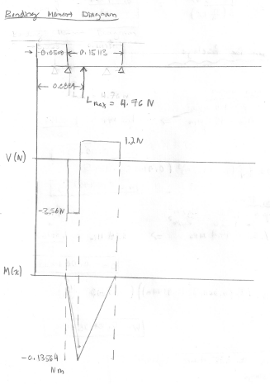
Figure 7: Bending Moment Diagram for Circular Fuselage

From the bending moment diagram the max bending and shear stress can be calculated. Respectively equations 2 and 4 display the bending and shear equations for a circular cross-section [11]; equation 5.1.1.4 is shown below.

 | $$τ_{max}=\frac{4V}{3A}$$ | (5.1.1.4)

Using the calculated values from Figure 7, equations 5.1.1.3 and 5.1.1.4 yield, σ_{max} = 1.38162/ D³ and τ_{max}= 6.0436/ D². Plugging in yield strength values for balsa and carbon fiber, where carbon fiber is equal to 474 MPa [15], the equation then equals a diameter of 0.00452 m for balsa and 0.001433 for foam. Using these diameters in conjunction with the material’s density values, 130 kg/ m³ [12] for balsa and 1760 kg/m³ for carbon fiber [15]; the mass of circular fuselage for balsa is equal to 0.001907 kg and carbon fiber is equal to 0.002579 kg. Comparing these values provides a mass of balsa that is 1.35 times lighter than balsa.

5.1.1.2 Material Analysis Conclusion

From these calculations it is shown for both cases, wing and fuselage, which material is the lightest as well as strongest to withstand the maximum forces that are present dunging flight. For the wing material foam is chosen as a candidate because it provides the lightest weight possible while holding a relatively high yield strength in comparison to balsa wood. Also, if the aircraft were to crash during the competition, foam is easily repairable with CA foam safe glue. Balsa is not as easy to repair because the wing would have two sections; one made of an outer shell called monokote, and the other, balsa wood construction. If the monokote is torn from the crash it is almost impossible to repair the wing without rebuilding the outer shell. For the fuselage carbon fiber is chosen as a candidate because of its high yield strength as well as it lightness. In comparison with balsa wood, carbon fiber’s yield strength is 31.6 times stronger. Though balsa is lighter than carbon fiber by 1.35 times, it is an insignificant amount. Since, the yield strength of carbon fiber outweighs balsa and the weights of both are comparable; carbon fiber is chosen as the material for the fuselage. From the analysis, it is concluded that foam will be used for the plane’s wing and carbon fiber will be used for the fuselage.

5.1.2 Fuselage Analysis

Dimensions and parameters of the fuselage for the SAE Aero – Micro competition are a key component to a successful aircraft. The primary purpose of the contest is to design an aircraft which has the lowest empty weight possible, while providing the maximum payload carry possible. There are various regulations within the competition rules that must also be met. Since our team is given a limited budget, we must be efficient with selecting shape, size, and material of the fuselage. The issue with the fuselage design is that we want it to be aerodynamic and generate maximum lift, but it is also necessary to have the lift remain stable with a payload added.

To decide which parameters will be most effective for the competition, we must first look at strength of material. For the fuselage, we debated between using foam and carbon fiber as the material. Since the strength of carbon fiber is much greater, we decided to use this material. Also, its durability reduces the potential for repair. Although the density of foam is less than that of carbon fiber, the carbon fiber fuselage will be hollow, allowing empty weight of the aircraft to remain sufficient. A hollow fuselage will also provide room for the electrical components.
The length of the fuselage will be 0.75 times (75%) the length of the wings based on a variety of classic aircraft to generate a streamlined body [16]. Given the total wingspan of the plane will be 3.5 feet in length, the length of the fuselage will be calculated as follows:

Fuselage Length = 0.75*(3.5 feet) = 2.625 feet = 31.5 inches

Per the rules of the competition, the cross-section of the fuselage must fit inside a 6-inch diameter round tube. We would like the diameter of the fuselage to be significantly smaller than the wingspan to allow the thrust from the propeller to be generated under the wings. Based on research of existing full-scale aircraft, the wingspan will be approximately 9 times the fuselage diameter [17]. Since the wingspan of our aircraft is given at 3.5 feet, the diameter of the fuselage will be given as follows:

Fuselage diameter = (3.5 feet) / 9 = 0.3889 feet = 4.667 inches or 4 2/3 inches

The fuselage will be tapered down toward the tail to influence the center of gravity and generate lift at the wings of the aircraft. This will also reduce the material used and the overall empty weight of the aircraft. The point at which to start tapering down the fuselage will be dependent on which point generates a center of gravity at the center of the airfoil. The center of gravity will be dependent on size of airfoil, tail wing and rudder, weight of the motor, number of propellers, etc., so exact tapering point will be determined after completed analysis of all components.

The cross-sectional shape of the airfoil shall benefit the taper design. Modern sailplanes as well as a number of modern propeller aircraft feature a “tadpole fuselage” in which the shape resembles that of a tadpole [18]. This tadpole design generates less drag due to its shape sustaining a laminar boundary around the fuselage. A general depiction of the idea is shown below.

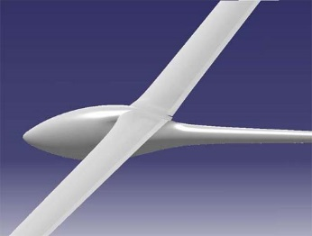
Figure 8: Tadpole Fuselage [19]

Fuselage Detail Summary
Material: Carbon Fiber (hollow)
Cross-section shape: Round
Fuselage Length: 31.5 inches
Fuselage Diameter: 4 2/3 inches
Tapered down (front to back)
Tadpole Fuselage

5.1.3 Wing Analysis

The team discussed which of the ten concepts would be the best for competition. The team agreed that concept 1 has the best chance in having the highest lift with the highest payload fraction. However, the team had disagreements on what type of the wing to use for the design. depicts a decision matrix to decide the best of the five wing types that would be potentially be great for the competition.

Table 6: Decision Matrix
 |  |  |  |  |  | Concepts
Criterion | Weight | High Mount | Score | Flaps | Score | Expandable | Score | Delta | Score | Biplane | Score
Safety | 0.23 | 10 | 2.3 | 7 | 1.61 | 5 | 1.15 | 8 | 1.84 | 8 | 1.84
Weight | 0.18 | 9 | 1.62 | 8 | 1.44 | 10 | 1.8 | 8 | 1.44 | 4 | 0.72
Durability | 0.13 | 8 | 1.04 | 7 | 0.91 | 4 | 0.52 | 9 | 1.17 | 7 | 0.91
Payload | 0.23 | 9 | 2.07 | 8 | 1.84 | 7 | 1.61 | 9 | 2.07 | 9 | 2.07
Lift | 0.23 | 9 | 2.07 | 10 | 2.3 | 7 | 1.61 | 8 | 1.84 | 8 | 1.84
 | 1 |  | 9.1 |  | 8.1 |  | 6.69 |  | 8.36 |  | 7.38

Of the top five concepts chosen for evaluation via the decision matrix, the “High Mount” wing design generated the highest weighted score. As previously mentioned, one of the primary objectives of this competition is to provide the lowest empty weight of the aircraft possible while also providing the highest payload carry. Disregarding the scores, the High Mount concept satisfies these objectives based on the components selected to complete the design. The relative simplicity of this concept design will allow it to satisfy the “micro” size constraint of being able to fit inside a 6-inch diameter round container. The components selected will keep the design lightweight while providing the potential payload fraction (payload carry divided by empty weight) necessary to compete and thrive in the competition.

5.1.3.1 Material

Before the team began the individual research, the team discussed what the material of the wing should be. The team agreed that we would use foam because of its lightweight yet sturdy attributes. The team wants to be able to test the plane frequently, which is another big reason we selected foam. The foam is easy to cut and it can easily be replaced if something were to happen to the aircraft. Figure 9 below demonstrates the material that we will be using. However, this is not our design.

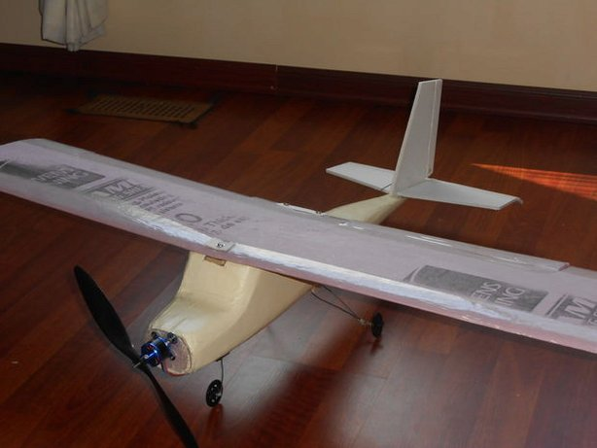
Figure 9: Pink Foam Material [20]

5.1.3.2 Airfoil Selection

To begin the selection process, I calculated the theoretical Reynold’s number that the plane will be operating at. Using a theoretical speed of about 5 meters per second, the Reynolds number can be found using equation 5.1.3.1 below [21].

 | $$Re= \frac{ρVc}{μ}$$ | (5.1.3.1)

Where ρ is the density of the air, V is the vehicle velocity, c is the chord length, and μ is the viscosity. All calculations are done using number associated with Fort Worth, Texas. Fort Worth is around 600 feet above sea level, so all calculations will be done using sea level numbers. Ρ is about 1.2 kg/m^3, c is 5 inches (.127 meters) and μ = 1.8 x 10^-5 kg/(m*s) [22]. We selected a chord length of 5 inches because of one of the design requirements that was provided by SAE. The parts of our plane must fit into a 6-inch cross section. The team agreed on a chord length of 5 inches because that is a reasonable length so that there is still room in the cross section.

$$Re=\frac{\left(1.2\frac{kg}{m^{3}}\right)\left(5\frac{m}{s} \right)\left(0.127 m\right)}{1.8\frac{kg}{m*s}}≈42,000$$

At such a low Reynold’s number, an under cambered airfoil is excellent for generating high amounts of lift [23]. Another important aspect of the airfoil is the max percent thickness. The percent is the ratio of the thickness to the chord length of airfoil. For a low Reynold’s number, a thickness around 12 – 17 percent is ideal. Numerous airfoils demonstrated value to the design criteria. The airfoils that were considered are in the labeled in table 4 below.

Table 7: Potential Airfoils
Airfoil | Max Cl/Cd at Re = 50000 | Max Thickness
EPPLER 560 | 31.1 | 16.1%
EPPLER 561 | 26.9 | 16.9%
FX-63-120 | 40.0 | 12.0%
GOE 190 | 37.2 | 12.7%
GOE 430 | 36.5 | 13.4%

A reasonable decision for our aircraft is the GOE 430 airfoil. It has a great Cl/Cd ratio and the thickness is reliable in flight. The GOE 430 boasts a great balance of sturdiness and aerodynamic capability. Airfoiltools.com provides excellent graphs on every airfoil. The Cl vs alpha is shown in figure 10 below.

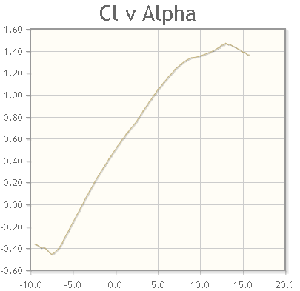
Figure 10: Cl vs alpha
5.1.3.3 Aspect Ratio

The aspect ratio is also known as the slenderness of the wings. A higher aspect ratio refers to long, slender wings. A small aspect ratio refers to small and wide wings. Both high and low aspect ratios have their own benefits, but for different planes. For a sailplane or an RC plane, a high aspect ratio works more effectively. Since the aircraft travels at low speeds, it needs a large area to push down the air and generate more lift. At low speeds, the tip vortices are also very week so they do not interfere with drag enough to be a problem. For rectangular wings, the aspect ratio can be calculated using equation 5.1.3.2 [25].

 | $$AR=\frac{b}{c}$$ | (5.1.3.2)

Where b is the wing span and c is the chord length (same as above). The team agreed to have an aspect ratio ranging between the values of 8 and 9. The team agreed to use a wing span of 3 and a half feet because that gives an acceptable value for the aspect ratio like we want.

$$AR=\frac{42 in}{5 in}$$

5.1.3.4 Wing Analysis Conclusion

Overall, the analysis of the wing has led to the result in table 8 below. I believe that wing properties chosen will be suitable for the SAE Micro Aero design competition.

Table 8: Final Wing Properties
Airfoil | Chord Length | Wing Span | Aspect Ratio | Material
GEO 430 | 5 in | 42 in | 8.4 | Housing Insulation Pink Foam

5.1.4 Motor Analysis

There is a sequence of process which leads to the flight of an aircraft. The energy stored in the electric cells is chemical energy which is converted to electric energy and drives the electric motor. The electrical energy is converted into the mechanical energy in the motor. The motor drives the propeller with the help of load bearing. These processes are shown in figure 11

Figure 11: Sequence of Operations

Table 9: Comparison of AC and DC Motors
A.C Motor | D.C Motor
High Torque | Less Rotor Heat
No Permanent Magnet | Maximum Power Setting
Adjustable magnetic field strength | No losses in A.C to D.C conversion
Difficult to control | Simple
Optimal Power factor of 0.85 | High Power factor
Inexpensive | Expensive

Brushless DC Motor (BLDC Motor) provides good power to weight ratio and available in variable sizes which can produce output powers in kilowatts. It makes the aircraft design simple and lowers its weight. It enables the aircraft to ascend vertically rather than climbing vertically. It has an inner rotor placed at the center of the motor. The stator windings surround the rotor completely. The rotor is located along the core which provides an easy dissipation of the heat. This arrangement provides a high torque output from the motor. The load power and load torque are given by equations 5.1.4.1 and 5.1.4.2, respectively.

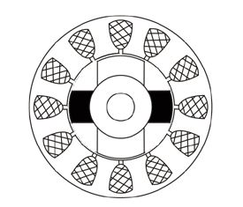
Figure 12: Inner Rotor

 | $$P_{load}=22.4{\left(\frac{w_{m}}{120π}\right)}^{3}KW$$ | (5.1.4.1)

 | $$T_{load}=\frac{P_{load}}{w_{m}}$$ | (5.1.4.2)
 | $$T_{load}=4.18*{10}^{-4}w_{m}^{2} N.m$$ | (5.1.4.3)
The selected BLDC motor has a speed of 3600 rpm for which w_{m}=120 π. Plugging this value we get a T_{load}=59.4 Nm.

Hence the BLDC motor provides high lifting torques of about 59.4 N.m. The torque speed characteristics of the motor are shown in figure 13. It is clear that at the start it offers a high constant starting torque to help in lifting the aircraft. The armature voltage of motor is provided by a battery of 11.1 volts. As the speed of motor increase the aircraft starts to lift, the torque provided by the motor decreases exponentially. The power of the motor remains constant during this process. The speed of motor is controlled by the field current in the windings of stator.

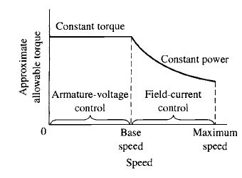
Figure 13: Torque Speed Characteristics

The model of our BLDC motor is NEMA GM33Y-3612200 and it has the following characteristics

Table 10: Ratings of the BLDC Motor
No. Of poles | 4
No. Of phases | 3
Rated voltage | 12 V
Rated Speed | 20000 RPM
Continuous Stall Torque | 2/44.6 Nm
Rated Torque | 60 Nm
Peak Torque | 70 Nm
Rated Power | 25 Watt
Weight | 100 grams

5.1.4.1 Electronic Controller Placement

A sensor is used to estimate the position of the rotor and outputs the signal to an electronic sensor which energizes the coil of motor. This process is shown in figure 14. A hall effect sensor is often placed in the BLDC motor because of its small size and good accuracy.

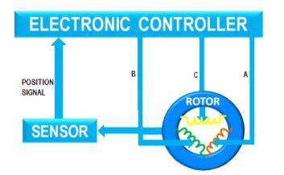
Figure 14: Sensor Based Control of BLDC Motor

5.1.4.2 Benefits of Electric Propulsion

Electric motor is 95% efficient as compared to internal combustion engines which have efficiency of only 18-23%. The amount of heat produced by the electric motors is very less as compared to the internal combustion engines. Electric motors are simple to operate and require less maintenance. We need only batteries, motor and controller to run the system which reduces the chances of system failure. The electric motor can be controlled easily with the help of a simple voltage regulator. The overall reliability safety and cost of maintenance reduces.

5.1.5 Propeller Analysis

5.1.5.1 Propeller of a Micro Aircraft

Selecting an appropriate propeller is critical for optimization of the performance of a micro aircraft. If the propeller is not appropriate for the aircraft, it may damage the components. A propeller is composed of vertically mounted wings. Propeller extracts engine power and converts it into thrust to push the plane in air. There is a twist in the propeller to create the angle of attack for each blade similar to a wing. It is shown in figure 15.

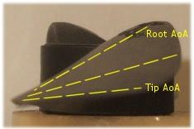
Figure 15: Propeller Blade

The size of twist increases towards the hub of the propeller because the airspeed varies along the lengths of air blades o vary the thrust generation. Tips of the propeller blades move with greater speeds as compared to the inner portions of the blades so there is a difference in thrust generation.

5.1.5.2 Propeller Sizing

For propeller sizing we use the chart shown in figure 16 for selecting propeller of appropriate size. The engine displacement is selected along the bottom scale and the vertical line is followed to select the propeller size for that dimensions of engine. The propeller dimensions are provided for various ranges of engine sizes. For example, a 0.9 engine would need a propeller range of 13x6 to 15x8.

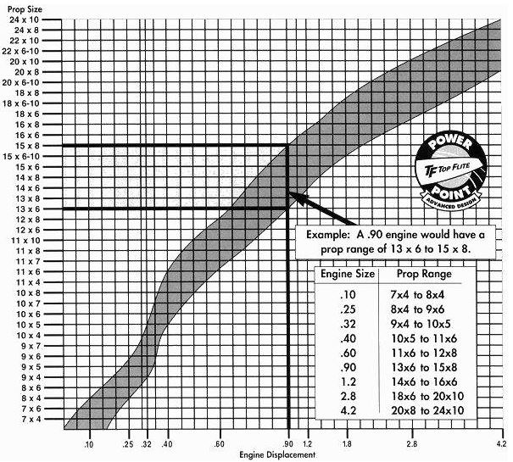
Figure 16: Propeller Sizing Chart

5.1.5.3 Propeller Blades

The propeller having three blades is selected for micro aircraft. It is efficient and cheap. Increasing the number of blades may reduce the efficiency of aircraft because each added blade will cut more turbulent air from the preceding blade. For low speed airplane and rpm, a 3 blades propeller will increase the thrust by 1.5 because of the added surface area. A common three blade propeller is shown in figure 17.

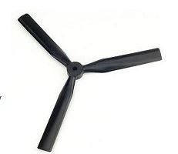
Figure 17: Three Blade Propeller

5.1.5.4 Propeller Calculations

Table 11: Dimensions for the Team's Design
Diameter (inches) | 52 56 59
Pitch (degrees) | 18 (14) 11
Thrust (lb) | 163 (179) 182

Incremental pitch angle=.57(18-11) = 4 degrees
Pitch at 52 inches=18-4=14 degrees
Incremental thrust increase=.57 x (182 lbs – 163 lbs) = 16 lbs
Thrust at 52 inches=16 lbs
Thrust at 156 inches=179 lbs

5.2 Design Description

The team selected a final design based off past experience as well as the analysis of the individual parts of the aircraft.

The wings and tail will be made with the pink house insulation foam. The wings are three and a half feet long and are cut into the GOE 430 airfoil. The horizontal stabilizer and rudder will both be made of the standard Clark Y airfoil. The wings and tail can be found in figure 18.

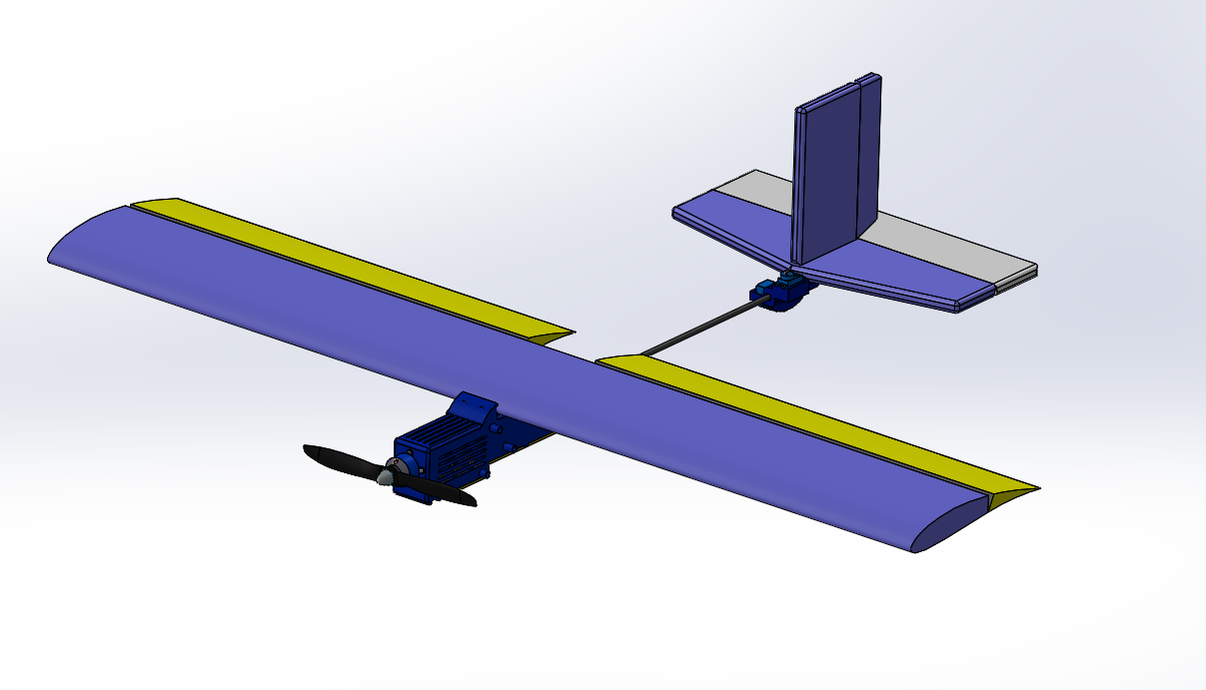
Figure 18: Complete Design

Last semester the team agreed that the fuselage would be made out of a circular carbon fiber rod, but the team was able to find more success using two pieces of rectangular carbon fiber rods glued together. The team has selected the NEMA GM33Y-3612200 motor to use for the aircraft. Last semester, the team decided to use a three-blade propeller rather than a two-blade propeller. However, this semester the team has decided to use the two-blade propeller since it is slightly lighter than the three-blade. The requirements in the SAE aero micro rules and regulations state that the team needs a payload pay that has the dimensions of 1.5” x 1.5” x 5”. The payload bay is infused inside the body of the plane. Figure 19 displays the body of the plane, with the payload bay.

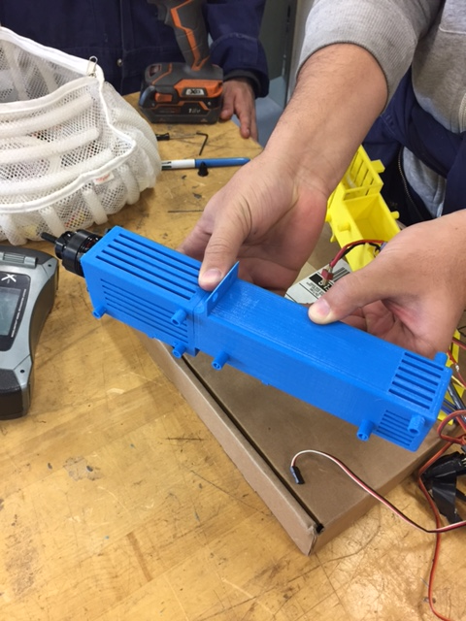
Figure 19: Body with Payload Bay Assembly
The team also must construct a container that has a cross section of 6 inches. The design of the container is not difficult because the team only has to make a tube that has a diameter of 6 inches. Figure 20 displays the material that the team used to construct the container. It is a 6-inch diameter poster board. The entire plane (excluding the propeller, red arming plug, and battery) must be able to fit into this cross section. The container plus the plane also cannot weight more than 10 pounds.

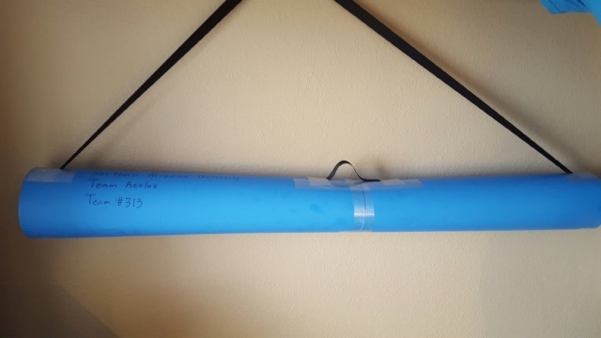
Figure 20: Dryer Duct Material to make the Container

6. Proposed Design

Figure 21 displays the final aircraft that the team created for the competition.

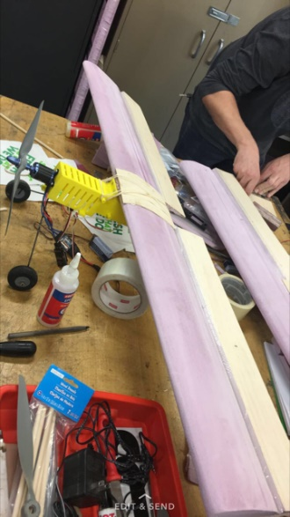
Figure 21: Final Aircraft

6.1 Bill of Materials

The table below shows the bill of material to design our SAE airplane project. We made a list of the parts we purchased. It includes the description, quantity and the cost of the parts. We are going to use one motor with low rpm to increase the thrust created to ensure carrying the maximum weight. A Three-blade propeller will more efficient in the low speed airplane because of the additional surface area. The reinforced tap will be used as joints for the aileron and the elevator. The square carbon fiber rod has dimensions of 8mm*8mm*1000mm as calculated. The Velcro strap is to place the speed controller (ECS) and the Battery and prevent them from moving during the flight.

Table 12: Bill of Materials
Part# | Part name | Description | Qty | Cost $ | Sourcing
1 | Motor | 11.1v, 860Kv, 9,546rpm | 1 | 23.66 | Hobby King [27]
2 | Reinforced Tape | Tape used as joint for Aileron and Elevator | 1 | 6.00 | Staples
3 | Propeller | 2 Blades propeller 12 in x 6 deg. | 1 | 3.00 | Flagstaff Hobbies
4 | Carbon Fiber rod | 0.23in hollow circular rod | 1 | 11.6 | Flagstaff Hobbies
5 | Velcro strap | To prevent some components from moving during the flight | 2 | 2.74 | Home Depot
6 | Battery | Battery for the plane | 1 | 15.00 | Already Owned
7 | Foam Sheet | Foam used for wings, tail, and stabalizer | 1 | 20.00 | Home Depot
8 | 3D Printing | Overall cost of 3D printing |  | 25.00 | Maker Lab NAU
9 | Arming Plug | Arming plug for aircraft | 1 | 15.00 | Custom Made
10 | Dryer Duct | Dryer duct used as container | 1 | 12.00 | Home Depot

6.2 Updated Schedule

Figure 22 below displays the team’s final schedule before competition. Everything that the team needs to do to prepare for competition is accounted for in the schedule. The competition is next week on March 10.

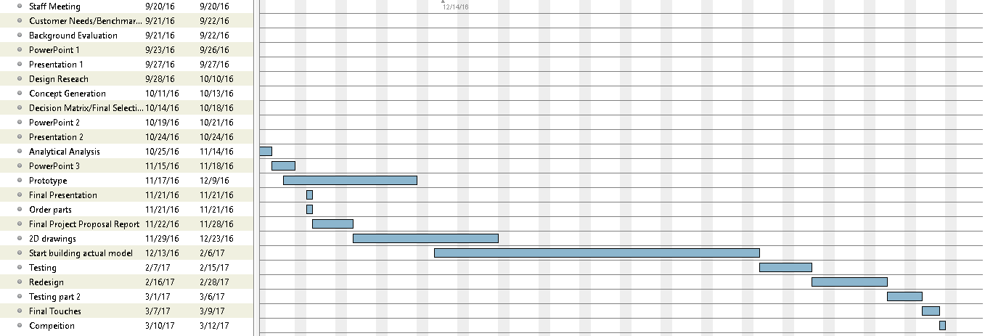
Figure 22: Final Schedule for the Team
7. Implementation

7.1 Manufacturing

The team constructed the aircraft using many different resources. The team used a hot wire cutter for majority of the cutting of the foam. Small parts were cut using an X-Acto Knife. The team constructed a hot wire cutter rather than buying one to save money. Figure 23 displays the hot wire cutter originally made by the team.

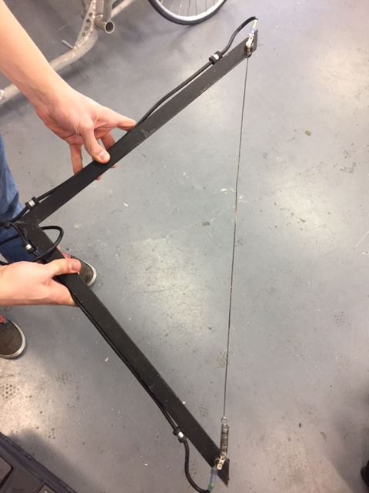
Figure 23: First Hot Wire Cutter Made by the Team
However, the team eventually decided to increase the size of the wings, so that the wings would be able to generate enough lift to stay in flight. Since the team increased the size of the wings, the team needed a larger hot wire cutter. Figure 24 shows the second wire cutter made by the team.

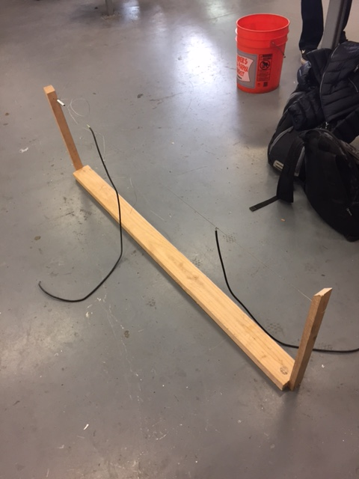
Figure 24: Second Hot Wire Cutter Made by the Team

The team heavily used the 3D printing that the library offers as well. The body of the plane and the tail mount is entirely 3D printed. The GOE 430 airfoil was also 3D printed so that the team had a guide when using the hot wire cutter. The team used balsa wood to make the ailerons and some of the connectors, like the connection between the rudder and the tail mount. The team bought everything else that is part of the plane, like the arming plug, propeller, motor, battery, and servos.

7.2 Design of Experiments

The team decided to make a design of experiments on the hot wire cutter that the team made. When the team first made the hot wire cutter, it was not enough to cut through the foam to make the wings of the aircraft, so the team created multiple variables to see which would be the most acceptable for cutting the aircraft.

Table 13: Design of Experiments for Hot Wire Cutter
Trial | Length of Wire (in) | Battery Used | Type of Wire | Temperature (F)
1 | -1 | -1 | -1 | 250
2 | 1 | -1 | -1 | 150
3 | -1 | 1 | -1 | 500
4 | 1 | 1 | -1 | 450
5 | -1 | -1 | 1 | 350
6 | 1 | -1 | 1 | 300
7 | -1 | 1 | 1 | 800
8 | 1 | 1 | 1 | 650

For the length of the wire, -1 represents a 18 inch wire while 1 represents a 42 inch wire. For the battery used, -1 represents a 11.1 volt, 1.2 amp battery while 1 represents a car battery (12.6 V, 550 CCA ). Lastly, the type of wire is a E guitar string for -1 and a copper infused wire that was given to the team for 1. The table clearly shows that the short wire with the car battery and the copper infused gave the best temperature. However, the team needed the longer wire to cut the long wings, so the team went with the combination for trial 8. The long copper infused wire connected to the car battery was sufficient for us to cut the wings.

8. Testing

The team tested the customer requirements necessary to pass inspection for participation in the competition. There were a variety of customer requirements needed to pass inspection, including specific payload dimensions, weight constraint, and dimensions that has to correlate to the 2D drawing submitted before the event. At the competition, the team passed inspection successfully, meaning all customer requirements were satisfied. A full list of customer requirements needed to pass inspection can be found here:

http://www.saeaerodesign.com/content/saechecklistmaster2017-1-102816micro.pdf

Most of the requirements were dimensional; the team measured the sizing of all dimensions in order to follow the requirements. The team was not able to test parts individually because that would have taken too much time before the competition. The team did test the entire aircraft before and after the competition however. The team recorded a successful flight before and after the competition, however the test flight before the competition resulted in a broken rudder. The test after the competition was a successful flight simulated similarly to the competition circuit. All of the customer requirements mentioned in the beginning of the report had to be followed in order for the team to fly in the competition.

9. Conclusions

9.1 Contributions to Project Success

The team worked hard to get all of the goals in the Team Charter done. All team members were a part of the successful flight of the aircraft. Throughout the year, the team had some minor issues and altercations but every problem was solved through the coping strategies in the Team Charter. For our team, we solved issues by bringing them up in team meetings and talking about how we could work differently so that everyone contributed. Our team’s greatest strength was the ability to not only work hard but also get along with each other so well. This team had plenty of laughs and jokes throughout the year and the team connected well. The most negative aspect of our team was time management. The SAE competition had much different deadlines than NAU. The team struggled to keep up with the requirements of SAE. 98C was a huge reason for our team’s success flying at NAU. The team would not have been able to get as much work done so fast if the machine shop was not there at NAU. The only problems the team encountered were some teammates arriving late to meetings. Other than that, the team worked well together. If the team were to do this project again, the team would understand the deadlines that they would have to meet in order to be successful at the SAE competition. The team learned a lot about RC planes. The team is more familiar with different types of airfoils and plane styles. The team understands that a hot wire cutter is an effective tool to create the wings of the plane and how precise 3D printing.

9.2 Opportunities for Improvement

If the team were to do this project again, the team would heavily stress on deadlines for the SAE competition. The team would also change the design so that it would not be so big. Other teams at the competition had smaller planes that worked well. The large container deducted points off the final flight score. The team learned a lot about the competition and the ideal ways to approach the competition. The team would not have participated in the timed event to get extra points. The presentation and the report were more important to the overall flight score than the team originally thought, so the team would have stressed the overall quality of the presentation and the report more.

10. References

[1] “About SAE International” 2016. [Online]. Available: http://www.sae.org/about/

[2] “2017 Collegiate Design Series: SAE Aero Design Rules” 2016. Available: https://www.saeaerodesign.com/content/2017_AERO_RULES_FINAL.pdf

[3] D. Coiro and F. Nicolosi, "Design of a Three Surfaces R/C Aircraft Model," 2002. [Online]. Available: https://ojs.cvut.cz/ojs/index.php/ap/article/viewFile/314/146. Accessed: Oct. 1, 2016.

[4] A. Bowers and O. Murillo. “On Wings of the Minimum Induced Drag: Spanload Implications for Aircraft and Birds.” NASA, March 2016. [Online].

[5] O. Bholse. “Radio Controlled Airplane” International Journal for Scientific Research & Development. pp 90-94. 2015.[Online].

[6] D. James, ": NASA quest > aerospace:,". [Online]. Available: http://quest.nasa.gov/aero/planetary/atmospheric/aerodynamiclift.html. Accessed: Oct. 1, 2016.

[7] O. Feather and T. Feather, "wing design," in aeronautics.nasa. [Online]. Available: http://www.aeronautics.nasa.gov/pdf/wing_design_k-12.pdf. Accessed: Oct. 1, 2016.

[8] A. Arbuckle, "Why use a whole plane when you can fly one wing?," Mashable, 1938. [Online]. Available: http://mashable.com/2015/09/01/flying-wing/#chcqwgS6qkqw. Accessed: Oct. 1, 2016.

[9] "Camberline." : Newsletter of the UIUC Low-Speed Airfoil Tests. N.p., n.d. Web. 27 Oct. 2016.
Available: http://m-selig.ae.illinois.edu/uiuc_lsat/lsat_5bulletin.html

[10] J. Anderson, Fundamentals of Aerodynamics, 5th ed. New York: McGraw-Hill Companies Inc., 2011, p. 24.

[11] R. Budynas, J. Nisbett and J. Shigley, Shigley's mechanical engineering design, 1st ed. New York: McGraw-Hill, 2011, pp. 92-97.

[12]"Balsa | Class 4 wood: slightly durable (CEN EN) | Wood | Polymer Matrix Composites (PMC's) | Natural & Synthetic Composites | Material Categories | Chemical, mechanical, physical and environmental properties of materials | Matbase: the independent online material selection resource", Matbase.com, 2016. [Online]. Available: https://www.matbase.com/material-categories/composites/polymer-matrix-composites-pmc/wood/class-4-wood-slightly-durable/material-properties-of-balsa-wood.html#properties

[13] 2016. [Online]. Available: http://depronfoam.com/depron-foam/resource/Depron-White-Technical-Data-Sheet.pdf

[14] "Engineering Values for model materials. - RC Groups", Rcgroups.com, 2016. [Online]. Available: https://www.rcgroups.com/forums/showthread.php?t=179292

[15] J. Corum and R. Battiste, "Basic Properties of Reference Crossply Carbon-Fiber Composite", Oak Ridge National Laboratory, 2016. [Online]. Available: http://web.ornl.gov/~webworks/cpr/v823/rpt/106099.pdf

[16] S. Pradyumna et. al., International Journal of Engineering Research and General Science Volume 3, Issue 4, July-August, 2015. Available: http://pnrsolution.org/Datacenter/Vol3/Issue4/117.pdf

[17] Airbus, Dimensions & key data | Airbus, a leading aircraft manufacturer, airbus. [Online]. Available: http://www.airbus.com/aircraftfamilies/passengeraircraft/a320family/a320/specifications/

[18] S. Gudmundsson, General aviation aircraft design: Applied methods and procedures. Butterworth-Heinemann, 2013. [Online]. Available: https://books.google.com/books?id=XtU4HVnWeZIC&pg=PA692&lpg=PA692&dq=drag+analysis+of+tadpole+fuselage&source=bl&ots=CfDhTDtNRJ&sig=GrgpiPveiUQryqvxPkJLVVJWViE&hl=en&sa=X&ved=0ahUKEwiKmeGj5rHQAhVr6oMKHXRPC8kQ6AEIGzAA#v=onepage&q=drag%20analysis%20of%20tadpole%20fuselage&f=false

[19] D. Sigler, CAFE foundation Blog - page 16 of 97 - information and discussion from the comparative aircraft flight efficiency (CAFE) foundation, CAFE Foundation Blog, 2015. [Online]. Available: http://cafe.foundation/blog/page/16/

[20] D. Bala. Foam RC Plane Building Guide [Online]. Available: http://www.instructables.com/id/Foam-RC-Plane-Building-Guide/

[21] Engineering Toolbox. Reynold’s Number. [Online] Available: http://www.engineeringtoolbox.com/reynolds-number-d_237.html

[22] Engineering Toolbox. Dry Air Properties. [Online] Available: http://www.engineeringtoolbox.com/dry-air-properties-d_973.html

[23] P. Johnson (2004-2005) About Airfoils for Flying Model Aircraft. [Online] Available: http://www.airfieldmodels.com/information_source/math_and_science_of_model_aircraft/rc_aircraft_design/plotting_airfoils/about_airfoils.htm

[24] (2016) Airfoil Database search. [Online] Available: http://www.airfoiltools.com/search/

[25] D. P. Raymer, “Airfoil Geometry and Selection”, in Aircraft Design: A Conceptual Approach: third edition. Reston, VA: AIAA Education Series, 1999, ch 4 pp 39 – 86

[26] “Turnigy 2217 20turn 860kv 22A Outrunner.” Hobbyking, hobbyking.com/en_us/turnigy-2217-20turn-860kv-22a-outrunner.html. Accessed 2 May 2017.

